Kenji Isak Laguan 101160737

Knowledge Base:

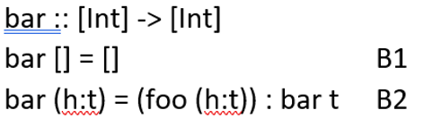

Inductive Case (IA): xyz (qux (bar (h:t))) = = (foo (h:t)) * (foo (h:t) + 1)

Prove this by structural induction: xyz (qux (bar x)) = = (foo x) * (foo x + 1)

**Base Case**: xyz (qux (bar [])) = = (foo []) * (foo [] + 1)

0 == 0 Q.E.D

**Inductive Assumption** (IA): xyz (qux (bar t)) = = (foo t) * (foo t + 1)

**Inductive Case** (IC): xyz (qux (bar (h:t))) = = (foo (h:t)) * (foo (h:t) + 1)

(1 + (foo t)) * (2 + (foo t)) == (1 + (foo t)) * (2 + (foo t)) Q.E.D